Crowd Funding Report

By: Ryan Blais

Conclusions Drawn

1. 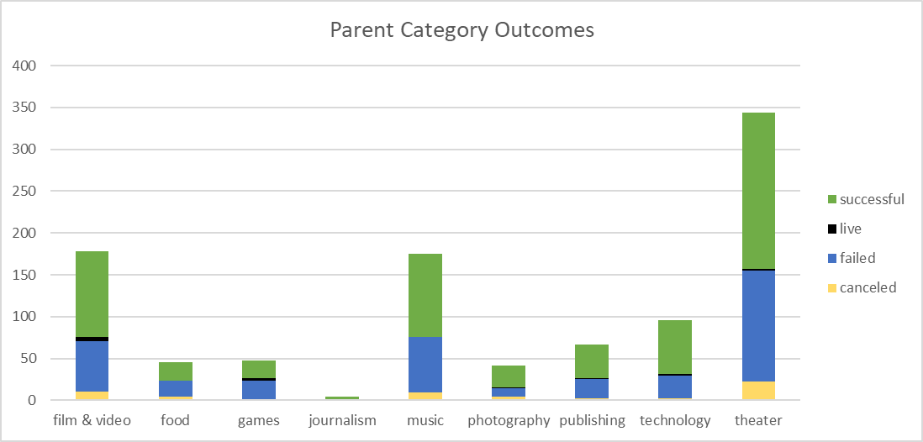Looking at the graph below, analyzing the different results for each “Parent Category” helps us to understand a few different things. One of them is how popular different categories were based on two different factors, how many campaigns were run and how successful they were. You can see that the “Theater” category not only had the most campaigns (344) but also had the most total successful campaigns (187). By this same admission, you can see that “Theater” also had the most total failed campaigns (132). Another thing you will notice is “Journalism”, which had the least number of campaigns (4), had zero failed campaigns.
2. If we look at the months when the campaigns started, you will see that in July more successful campaigns were started than in any other month. An interesting situation happened in August where the difference in campaigns started for successful and failed share an inverse relationship.

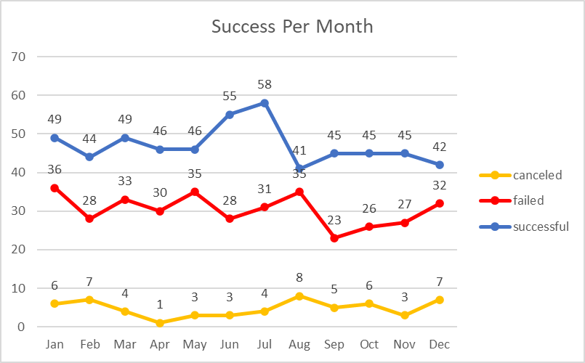

1. 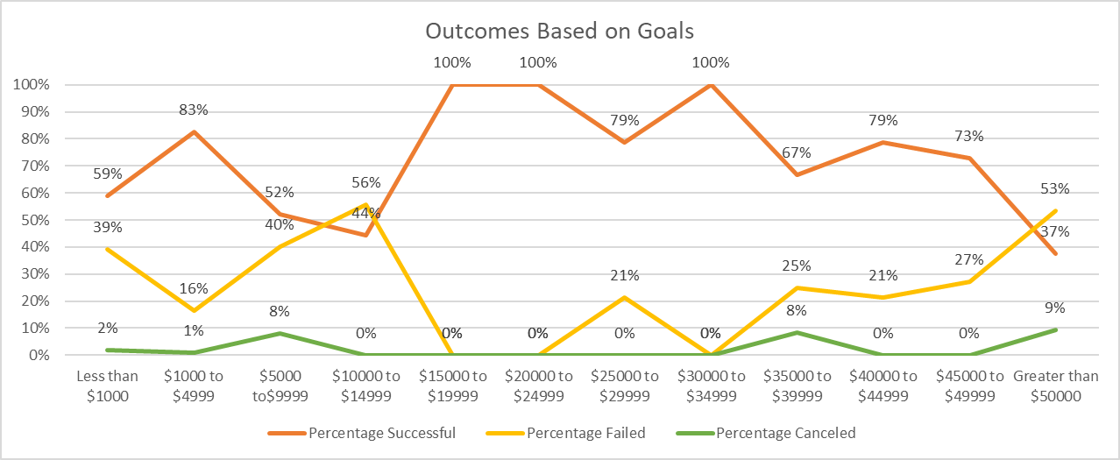Looking at the number goals vs outcomes we can breakdown how successful the campaigns were based on their goal number. I was surprised to see that there were not an overwhelming number of successful campaigns with a lower goal amount. The data is somewhat skewed on the chart because the 3 ranges with 100% success rate had a total of 24 campaigns between the 3 of them. Another data that could be misleading based on the chart alone is for the $10,000 to $14,999 range where there were more failed campaigns than successful, because that only considered 9 data points.

Limitations to the Data Set

* With most situations, the more data we have the better our analysis could be and the more insight we could provide.
* The currencies in this data set are not standardized. If we were to convert the dollar amounts into one standard unit, we might get a better idea of the total funds raised.
* There are many data sets where there are low figures of data, if we were to have more data in those ranges, we could get a more accurate understanding.
* Another area where the data could be analyzed is if we had demographics of those who donated. Whether it be by age, race, or sex. This could help determine who is most likely to contribute to which campaigns.